

MINI - PROJECT ON

**“Online Auction System”**

BY

1. Aman Bharti (2193032)
2. Gaurav Kumar (2193104)
3. Chinmay Mandavkar (2193088)
4. Aman raj (2193033)

**Under the Guidance of**

***Dr. Nilima Kulkarni***

DEPARTMENT OF COMPUTER SCIENCE & ENGINEERING

**MIT SCHOOL of Engineering**

Loni Kalbhor Pune

**INTRODUCTION**

The internet has become a very important aspect of Everyday life. The rate at which large populations are seeking to buy items is also on the rise, as many people are seeking advanced and ideal routes of trading services. Some people spend a lot of resources (money, time) on transportation, using a lot of time at the end of the road they might lack to get the desired items which they opted for.

It is open that most people are seeking to buy items every day in most cities and towns, both locally and abroad, desperate if they might get a solution or the right person to deliver a solution to them. These people end up settling at items or service providers who are common or who sell illegal and fake items to desperate buyers.

On the other hand, there are legit business people and store owners who have quality items in the locality of the auctioneer, but they do not meet for business because the auctioneer is not informed about the items available. This is great frustration indeed!

This project shall handle this issue by creating an online platform where a user will be able to post items online for auction. The items will accompany the item name, selling price, and a picture presentation for the bidder to see. This is important since the auctioneer does not necessarily need to make a physical consultation with the seller for him/ her to get the required services. The customers will be assured of getting the right products since they will take their time to analyze and compare a range of listed items and choose appropriately according to their needs or desire. In traditional auction houses, bidders had to sit through hours of auctioning just to bid for a specific item they desire. Online auction system will save time that buyers take in search of items and therefore they will save themselves from worsening conditions which may lead to wastage of time. This will also save money that is spent around traveling and bidding for undesired items. Bidders will at the end of the day have a reason to smile with this online system.

**PROJECT OBJECTIVE**

To develop an online auction system that will provide a platform for sellers to interact with buyers, and sell items to interested bidders.

The Online auction system shall accomplish the following as a way of achieving the major goal:

* Create a java application where bidders auction for items posted by the seller through the online system.
* Have a reliable user checking.
* To implement and test the work-ability of the newly developed system.

\

**REQUIREMENTS**

### User Interface Requirements

Simple Graphical user interface (GUI) for easy navigating through the program

Easy to update profile and items

Dynamically configurable interface

Search functions

Appealing to the eye through coloration and pictorial presentation

### Hardware Interface Requirements

Processor speed of 0.5 GHz or more for mobile gadgets

Processor speed of 1.5ghz or more for desktop and computer gadgets

Ram of 500Mb and above for all devices

Free storage memory capacity of more than 100Mb

### Communication Interface Requirements

Internet connectivity

### 

### 4.Development tools

* MySQL database
* Eclipse IDE
* Java swing

## PROJECT PURPOSE

To develop an online auction system which will provide a platform for sellers to interact with buyers, and sell items to interested bidders.

**The Online auction system shall accomplish the following as way of achieving the major goal:**

To build a user-friendly auctioning Java application, where users will be able to auction any product which is available nearby or anywhere in the world. By using Online Auction system, it will be easy for auctioneers to make an auction and time saving also. By making auctions through this application will help to reach the maximum of buyers bidding in the local area.

To implement and test the work-ability of the newly developed system.

**LITERATURE SURVEY**

Online auctions have become a pervasive transaction mechanism for e-commerce. As the largest online marketplace in the world, eBay is an attractive case study that enables the study of online auctions utilizing data involving real people and transactions. In this paper, we present a detailed investigation and analysis of multiple online auction properties including: consumer surplus, sniping, bidding strategy and their cross relationships. **Our goal is to evaluate the theoretical foundations of online auctions and discover patterns and behaviours hidden due to the lack of real and extensive transaction data.** Among our findings, we uncover an important correlation among sniping and high surplus ratios, which implies the uncertainty of true value in a competitive environment. The key issue is the wrong assumption that bidder’s valuations are independent from each other, which leads to inefficient auctions. In order to address the inefficiencies of current online formats we introduce a declining price auction model customized for online transactions. Conceptually, this model ought to deal with the complexities of competition in an online environment while maximizing social welfare.

In recent years, the proliferation of the World Wide Web has led to an increase in the number of public auctions on the internet. One of the characteristics of online auctions is that a successful implementation requires a high volume of buyers and sellers at its website. Consequently, **auction sites which have a high volume of traffic have an advantage over those in which the volume is limited. This results in even greater polarization of buyers and sellers towards a particular site.** This is often referred to as the network effect in a variety of web and telecommunication applications involving interactions among a large number of entities. While this effect has qualitatively been known to increase the value of the overall network, its effect has never been modelled or studied rigorously. In this paper, we construct a Markov Model to analyses the network effect in the case of web auctions. We show that the network effect is very powerful for the case of web auctions and can result in a situation in which one auction can quickly overwhelm its competing sites.

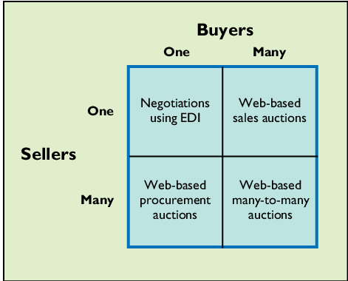

This results in a situation in which the natural stable equilibrium is that of a single online auction seller for a given product and geographical locality. While a single player structure is unlikely because of some approximation assumptions in the model, the trend seems to show the likely existence of a single dominant player in the web auction space.

Academic interest in the popularity and success of online auctions has been increasing. Although much research has been carried out in an attempt to understand online auctions, little effort has been made to integrate the findings of previous research and evaluate the status of the research in this area. **The objective of this study is to explore the intellectual development of consumer behavior in online auction research through a meta-analysis of the published auction research.** The findings of this study are based on an analysis of 83 articles on this topic published mainly in information systems (IS) journals between 1998 and 2017. The results indicate that the consumer behavior research on **online auctions can be categorized into three major areas facilitating factors, consumer behavior and auction outcomes**. Based on this literature review, directions for future research on auction consumer behavior are discussed, including potential new constructs, unexplored relationships and new definitions and measurements, and suggestions for methodological improvements are made.

This study seeks to answer the question of how an individual would trade off between **listing fee** (i.e., cost of listing an auction item) and **transaction probability** (i.e., the chance that a product will be sold). Applying the trade-off decision-making paradigm into the auction context, we examine a seller’s choice of online auction outlet and subsequent starting price strategies when facing the trade-off between transaction probability and listing fee. Results from a set of laboratory experiments suggest that a seller would be willing to incur a high cost in exchange for a higher transaction prospect. Furthermore, if the expected transaction probability is high, a seller is more likely to set a high starting price despite incurring a high listing fee. The implications for theory and practice are discussed.

Online auction is becoming more and more popular in electronic commerce (EC). It has become the mainstream trading methods in consumer to consumer (C2C), such as eBay. The steady collaboration field and common concept of exchange may be formed in the cooperation of the multi-agent system (MAS), and then the agents will have so much common knowledge in order to complete the tasks. The members of MAS have both cooperation and self-interest. Based on the analysis of the cooperation and competition of the participants in the online auction, the concept of overtime and history information is introduced. As existing incomplete information, the efficiency of the auction is low without considering the history information. This paper put forward a MAS flow frame and negotiation algorithms that make the bidders of the auction participate in the negotiation honestly and actively. Both the efficiency and transparency among the participants have been enhanced.

**Auction is an effective way to allocate goods or services to bidders who value them the most.** The rapid growth of e-auctions facilitates online transactions but poses new and distinctive challenges. **It is difficult to establish trusts among sellers, buyers and auctioneers without the centralized auction websites or platforms (the auctioneer) that collect bids and derive the auction results**. However, these third parties may be untrustworthy, and malicious sellers or buyers may refuse to deliver the goods or payment according to the protocol. Moreover, the open and anonymous online environment may stimulate auction participants to form collusion coalitions to rig the auction and reap unfair profit. Many auction designs have been proposed to address these concerns, but they fall short of simultaneously achieving decentralization (i.e., held without a trusted third utility), strong consensus (i.e., the establishment of trust), collusion resistance and practical implementation. **With the carefully-designed smart auction contract, mutually distrustful and rational sellers and buyers are stimulated to operate properly hence transact safely without trusted third parties.** The auction mechanism in the smart contract can effectively prevent bidder collusion and realize economic robustness, i.e., truthfulness.

## OVERALL DESCRIPTION

### 1. Product Perspective

 The following are the main features;

* Cross platform support – it offers operation support for most of the known and commercial operating systems including windows operating system
* User accounts – this system allows the system users to create system accounts, view and update their profiles.
* Users supported in the system – the system supports quite a large number of users at one time.

### 2. Product function

* Enable the users to view posted products with show item menu
* Enable creation of accounts and logging in to the accounts
* Enable users to logout of their accounts
* Provide an interface for the administrator to view the transactions, add sellers and items for auction to the system.

The sellers should also have accounts including their login and seller profile.

### 3. User characteristics

The system requires that the users be equipped with overall internet knowledge and the gadget accessing it. The administrator is expected to have more skills with the interface of the tech support system. The sellers should also have skills of well analyzing and navigating the internet usage and be able to handle customers who may not be so familiar with the internet.

### 4. Constraints

The choice of the database to use should be considered carefully, since there will be a lot of data traffic and the large amounts of data will also judge the database. A good database will yield speed querying of data.

The device should be enabled with internet

1. **Figures**

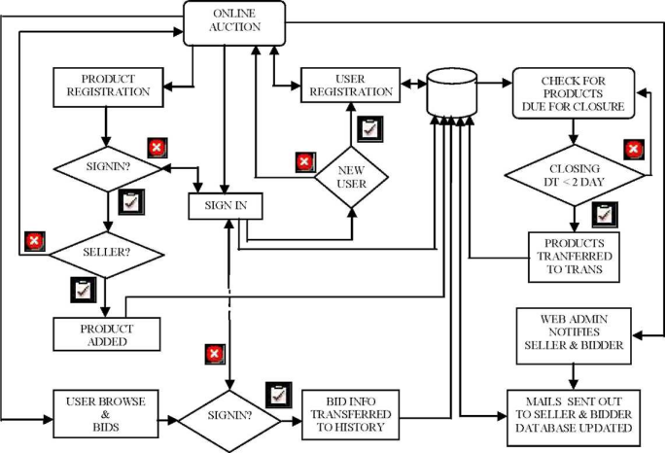

New User Registration

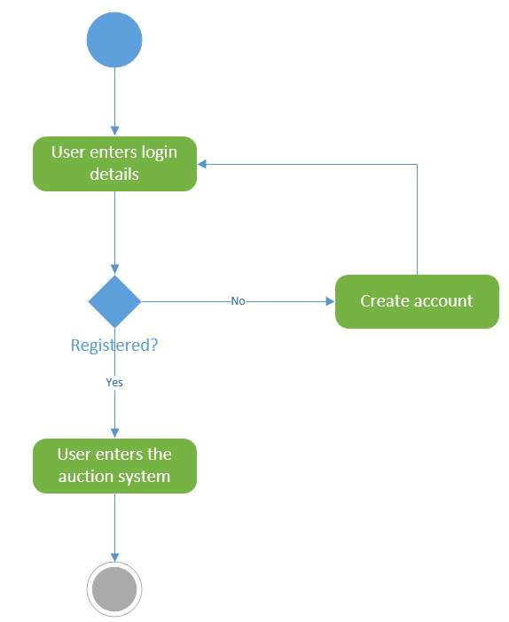

**Modules**

1. **Admin Login Page**

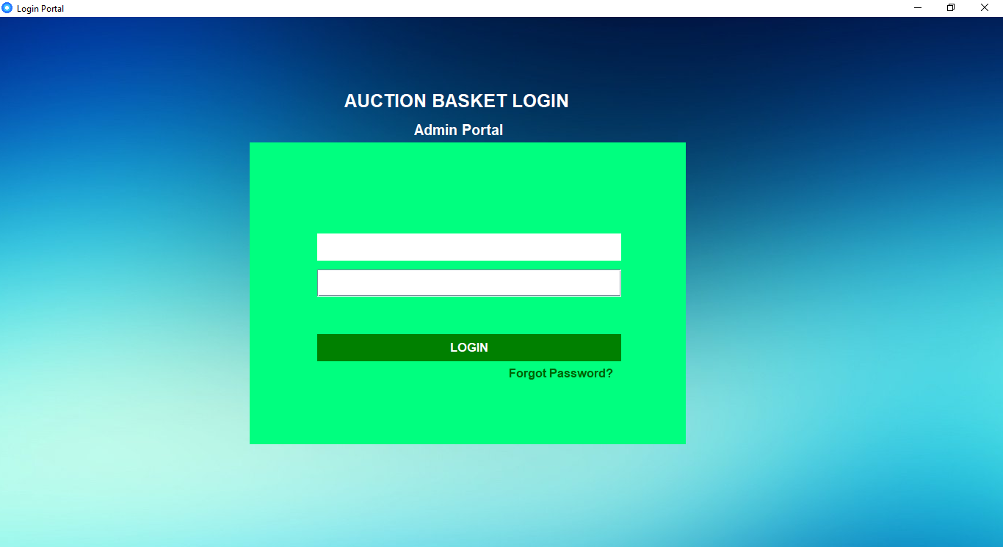

1. **Admin Home Page**

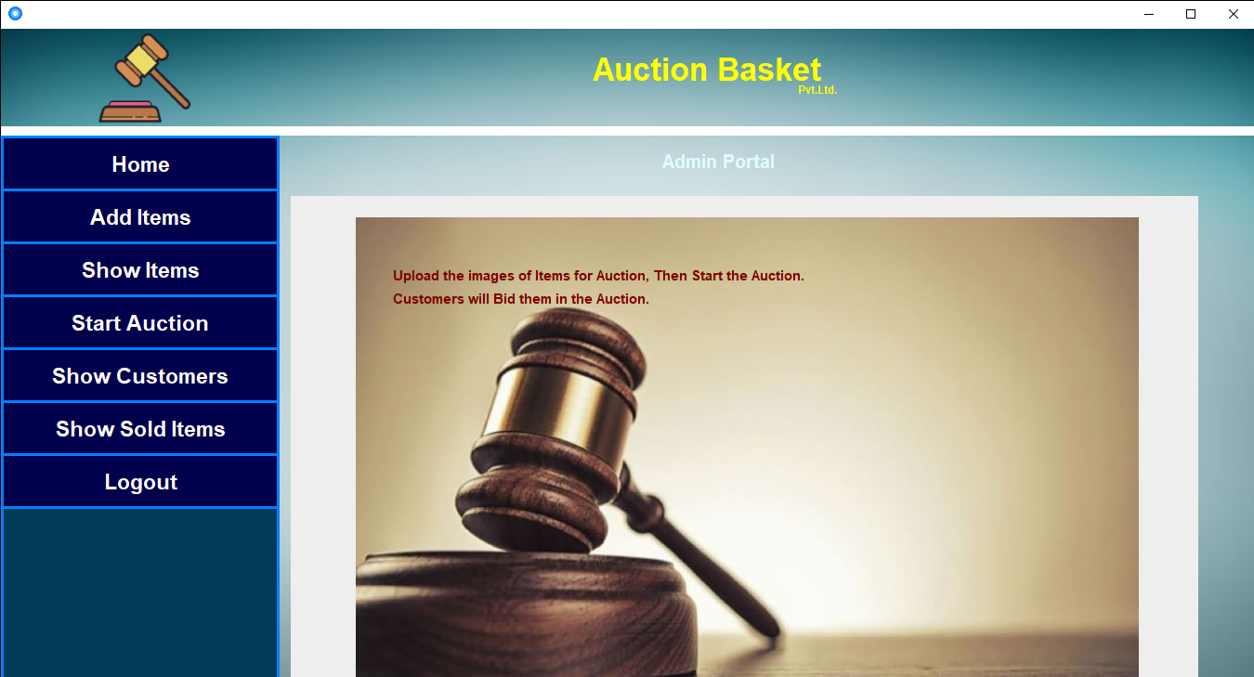

1. **Add item**

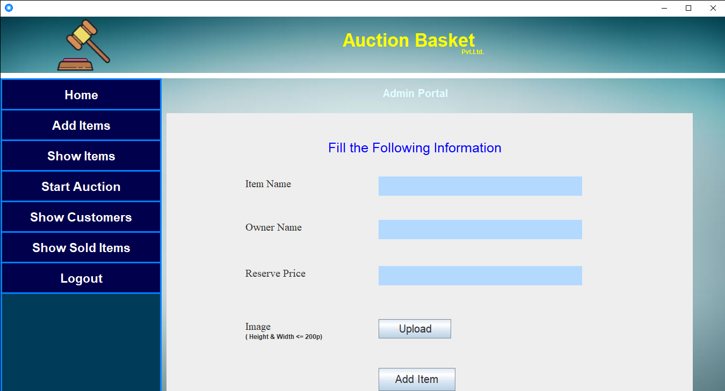

1. **Show Item**

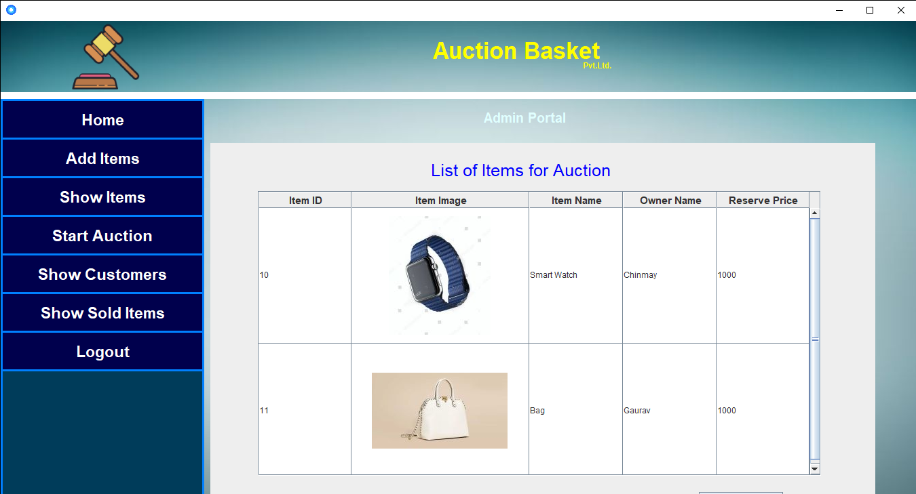

1. **Customer Login Page**

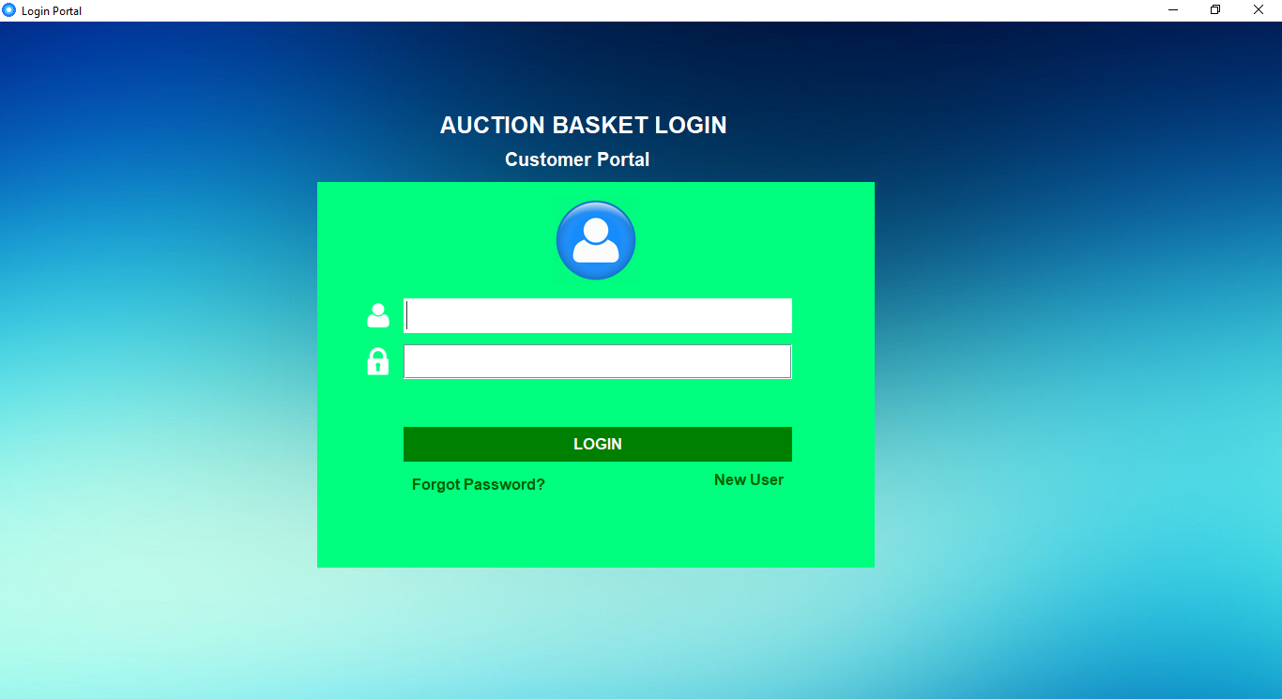

1. **Customer details**

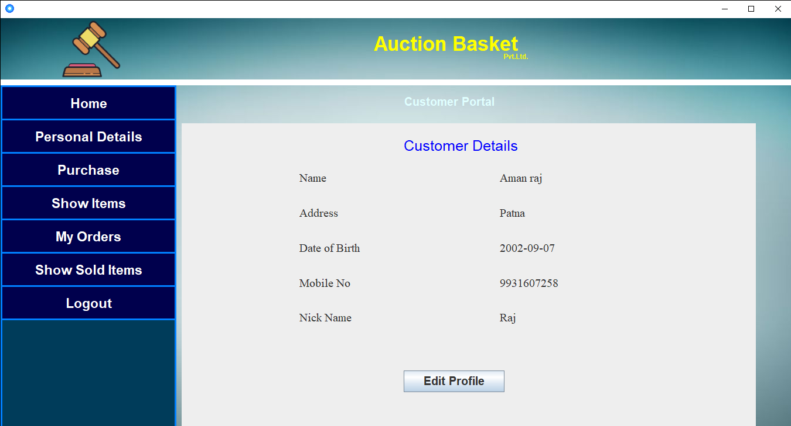

1. **Customer side item list**

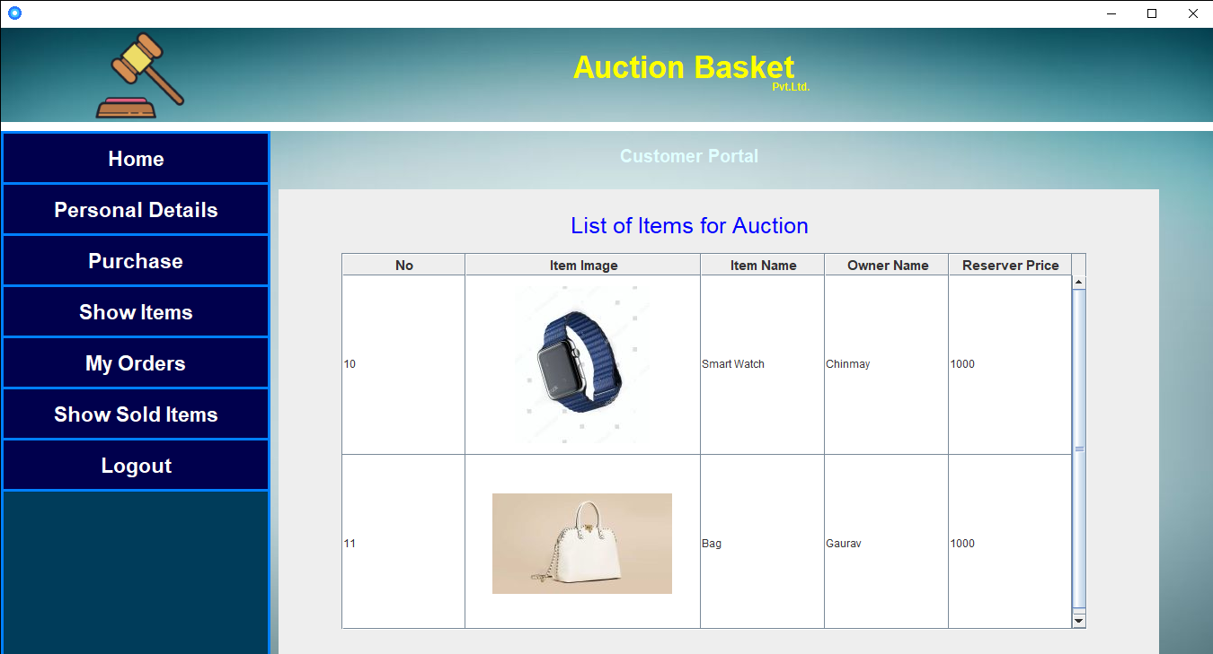

1. **Customer List**

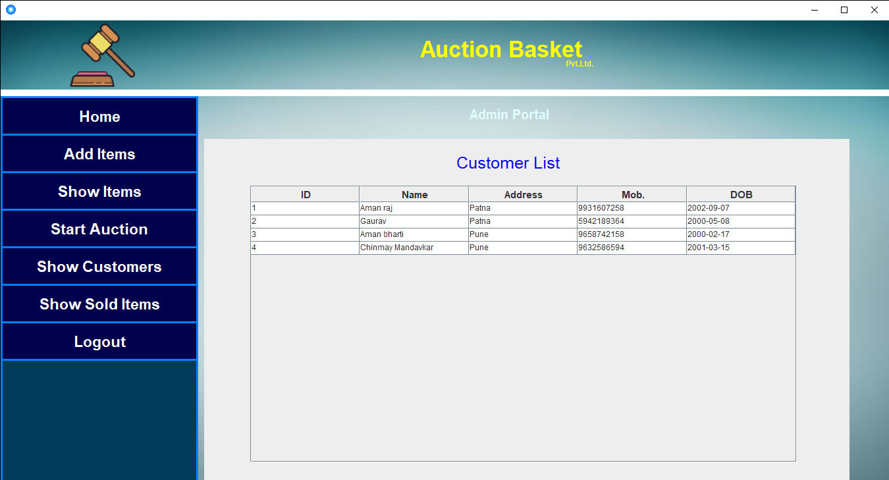

**Database Tables**

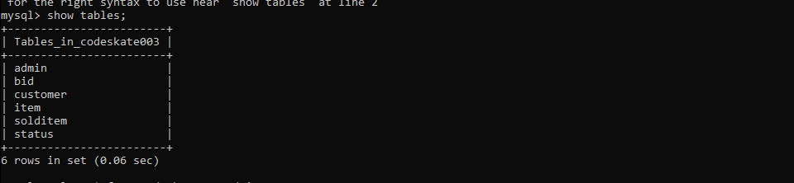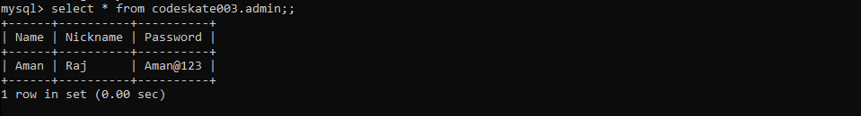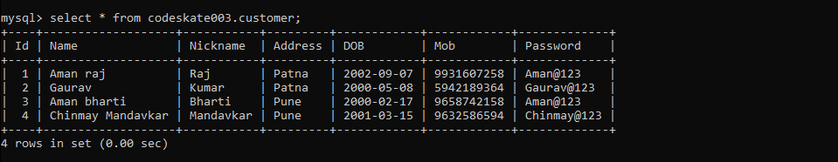

**Future Scope**

One of the main future enhancements of our system is to make it functioning with online transactions and interactions between buyer and sellers. We would also like to improve the security by adding the option of blacklisting defaulting bidders. There also can be options for rating sellers and products. Online payment settlement can be incorporated in the system. Real time chat boxes where sellers and customers can discuss with each other as well as public chat boxes can be incorporated in the system.

**Conclusion**

The developed system is flexible and changes can be made easily. The system is developed with an insight of the necessary modification that may be required in the future. Hence the system can be maintained successfully without much rework.

**Reference**

* YouTube
* GitHub
* **Dr. Nilima Kulkarni**
* Google

**THANK YOU**